114學年度理學院EMI計畫課程申請表
課程名稱  (中/英文) |  | 開課老師 |  | 學分數
專/兼任 | - 專任老師  - 兼任老師 | 開課學期 |  | 選課編號
是否同意加入理學院EMI計畫執行 | □不同意
是否同意加入理學院EMI計畫執行 | □同意  EMI計畫推動之教師須辦理事項如下:  (一) 填寫本申請表。  (二) 提供EMI課程TA名單。  (三) 填寫EMI課程資料授權同意書。  (四) 繳交結案報告。
理學院EMI計畫相關補助
EMI計畫補助項目 | 以下項目只能選一項：  □ 專任教師獎勵金(兼任老師業務費)-每學分補助5,000元  (是否向學校申請過獎勵金。□是 □否)  □ 1.5倍課程授課鐘點
EMI計畫補助項目 | 課程TA聘用需求：  □ 0人 □ 1人 □ 2人 □ 3人，參照以下TA申請說明(詳註1)。
額外補助 | □數位教材獎勵金-每月至多 6,000 元，上課期間須全程拍攝。

老師簽名：_______________
註1：課程助教(TA)補助申請規定
一、課程TA分配規定：
a. 修課人數10人(含)以上得申請課程教學助理(TA) 1名TA補助。
b. 修課人數30人(含)以上得申請課程教學助理(TA) 2名TA補助。
c. 修課人數達50人(含)以上得申請課程教學助理(TA) 3名TA補助。
二、TA英語能力達CEFR B2以上為最佳。 (需能參與學校TA培訓課程、研習工作坊及英文檢定(達B2級以上報名費可補助者)為優先。)
(1)每名英語程度達CEFR B2的TA工讀金：250元/hr*課程學分數*16週
(2)每名英語程度未達CEFR B2的TA工讀金：200元/hr*課程學分數*16週
(核發金額依當年度計畫核定金額調整，英語能力達CEFR B2之TA方得申請250元/hr，並請檢附英語能力之證明)
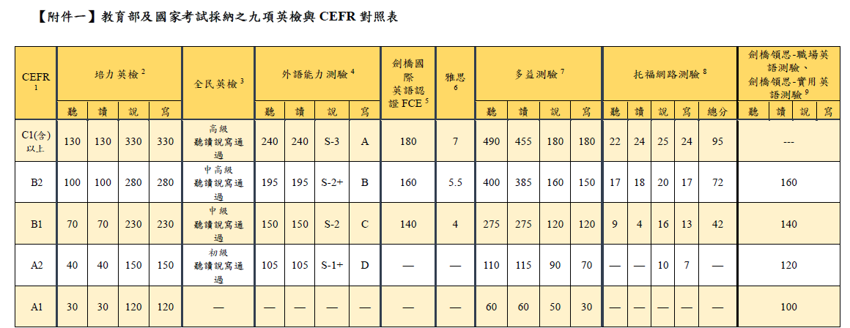

詳註2：EMI課程定義
與英語授課不同處，EMI課程相關定義及要求依教育部規定規範如下:
(1) EMI課程指涉的是專業領域課程以全英語方式授課(不含語言學習課程)。
(2) EMI課程授課內容、師生互動、學生學習及學術支持教材、學習成果報告、展示與評量皆須以全英語方式進行。
(3) 學生間台下分組討論可使用中文，提問及上台報告皆為英文，教師仍應確保至少70%班級溝通是以全英文進行。

聯絡資訊Contact Information
聯絡人Contact person：理學院emi計畫 廖亭雅 小姐 Miss Liao
電子郵件E-mail：emiscie@nchu.edu.tw
電話Tel：04-22840408 # 15
Application Form for EMI Program Courses of College of Science,
NCHU in 114 Academic Year
Course Title (Chinese/English) |  | Instructor |  | Credits
Employment Status | - Full-time Faculty  - Part-time Faculty | Semester |  | Course Code
Agreement to Participate in EMI Program | □ Not Agree
Agreement to Participate in EMI Program | □ Agree  Faculty Responsibilities under EMI Program:  1. Complete this application form.  2. Provide a list of EMI course TA.  3. Complete the EMI Course Material Consent Form.  4. Submit the Final Report.
EMI project Subsidy Options:
EMI Program Subsidy Items | The following item can only be selected once:  □ Full-time faculty bonus (Part-time faculty honorarium) – NT$5,000 per credit  (Have you applied for the bonus from the university? □ Yes □ No)  □ 1.5× teaching hours for the course
EMI Program Subsidy Items | TA Hiring Requirement:  □ 0 □ 1 □ 2 □ 3 (refer to Note 1)
Additional Subsidy | □ Digital Teaching Material Incentive – up to NT$6,000 per month (must record entire semester)

Instructor Signature：_______________
Note 1: Regulations for Course TA Subsidy Applications
I. TA Allocation Rules:
a. For courses with 10 or more students, 1 TA subsidy may be applied for.
b. For courses with 30 or more students, 2 TA subsidies may be applied for.
c. For courses with 50 or more students, 3 TA subsidies may be applied for.
II. Preferred English Proficiency:
- TAs with CEFR B2 or above are preferred.
- Priority is given to those who can participate in the university’s TA training courses, workshops, and English proficiency exams (registration fees for B2 or above may be subsidized).
TA Hourly Wage:
- TA with CEFR B2 or above: NT$250/hr × course credits × 16 weeks
- TA below CEFR B2: NT$200/hr × course credits × 16 weeks
(The approved amount will be adjusted according to the budget of the program for the current year. Only TAs with CEFR B2 or above are eligible to apply for NT$250/hr, and proof of English proficiency must be attached.)
Note 2: Definition of EMI Courses
The definitions and requirements of EMI courses, as regulated by the Ministry of Education, differ from general English-taught courses as follows:
- EMI courses refer to professional/disciplinary courses taught entirely in English (excluding language learning courses).
- Course content, teacher-student interactions, student learning, academic support materials, learning outcome reports, presentations, and assessments must all be conducted entirely in English.
- Students may use Chinese during small-group discussions off-stage; however, questions and presentations must be in English. The instructor must ensure that at least 70% of classroom communication is conducted in English.

Contact Information
Contact person：理學院EMI計畫 廖亭雅 小姐 Miss Liao
E-mail：emiscie@nchu.edu.tw
Tel：04-22840408 # 15

