115學年度理學院EMI計畫課程申請表
課程名稱  (中/英文) |  | 開課老師 |  | 學分數
專/兼任 | - 專任老師  - 兼任老師 | 開課學期 |  | 選課編號
 |  |  |  | 選課人數
課程類型 | □ EMI課程 □全英語授課之ESAP課程
是否加入理學院EMI計畫 | □不同意  註：勾選「不同意」者，免填本院計畫執行事項、院級補助及TA需求，惟仍請填寫下方「學校補助申請情形」。
是否加入理學院EMI計畫 | □同意，開設 □ EMI課程 □以全英語授課之ESAP課程  EMI計畫推動之教師須辦理事項如下:  (一) 填寫本申請表。  (二) 提供EMI課程TA名單。  (三) 填寫EMI課程資料授權同意書。  (四) 繳交結案報告。  包含：1.填寫EMI課程教學報告。  2.EMI課程TA必須參與 TA研習工作坊2次。  3.填報全英授課課程教學回饋問卷學生填答率達 80%。
全英語授課相關補助申請情形
- 雙語中心補助 | □ 已申請/預計申請學校全英語授課鐘點獎勵：1.5倍課程授課鐘點  □ 已申請/預計申請學校全英語授課：【□授課補助(獎勵金) □教材補助(業務費) 】  □ 未申請學校相關補助  ※本欄僅供本院了解申請情形，實際申請仍應依雙語中心規定另行辦理。
（二）理學院EMI計畫補助 | □ 申請院補助的專任教師獎勵金-每學分補助6,000元  □ 申請院補助的兼任老師業務費-每學分補助6,000元  ※本欄僅限同意加入理學院EMI計畫者填寫。  ※實際補助金額依本院當年度核定經費調整補助。
（二）理學院EMI計畫補助 | 課程TA聘用需求：  □ 0人 □ 1人，參照以下TA申請說明(詳註1)。  ※本欄僅限同意加入理學院EMI計畫者填寫。

老師簽名：_______________
詳註1：課程助教(TA)補助申請規定
一、課程TA分配規定：修課人數10人(含)以上得申請課程教學助理 (TA) 1名TA補助。
二、TA英語能力達CEFR B2以上為最佳。 (需能參與學校TA培訓課程、研習工作坊及英文檢定(達B2級以上報名費可補助者)為優先。)
1. 每名英語程度達CEFR B2的TA工讀金：250元/hr*課程學分數*16週
2. 每名英語程度未達CEFR B2的TA工讀金：200元/hr*課程學分數*16週
PS.以實際跟課時間支應薪水。
3. TA需參與學校或本院舉辦的TA培訓課程或研習工作坊2次，本院研習活動必須出席。
4. TA需協助完成老師的EMI結案報告，於學期末填報「全英語授課課程教學回饋問卷」學生填答率達成80%。
5. 課程無另申請 EMI課程 TA 補助，只要該課程有申請院級 EMI 課程獎勵，且實際有 TA 協助，該 TA 仍需遵守以上規定（包含參與工作坊、協助完成報告與問卷填寫率等）。
6. TA需加入115-1學期LINE群組，以利院做各項通知。
(核發金額依當年度計畫核定金額調整，英語能力達CEFR B2之TA方得申請250元/hr，請檢附英語能力之證明)
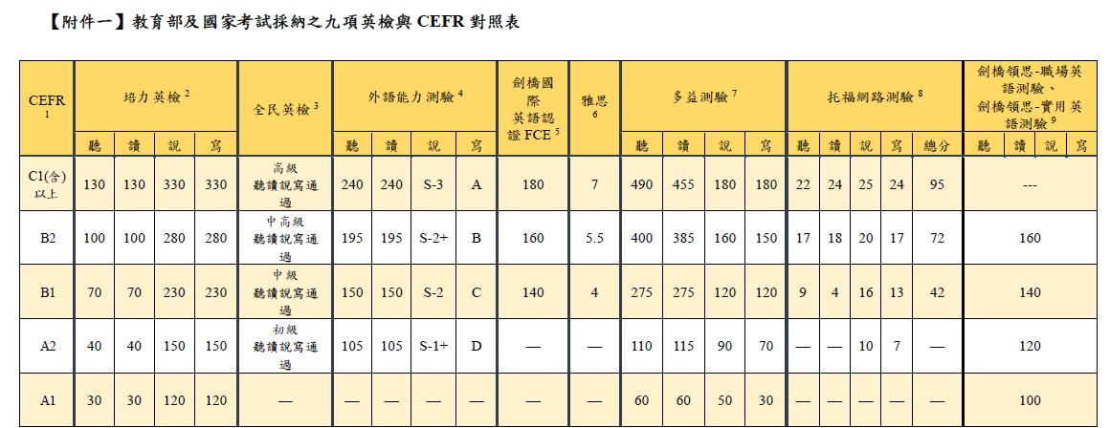
詳註2：EMI課程定義
與英語授課不同處，EMI課程相關定義及要求依教育部規定規範如下:
1. EMI課程指涉的是專業領域課程以全英語方式授課(不含語言學習課程)。
2. EMI課程授課內容、師生互動、學生學習及學術支持教材、學習成果報告、展示與評量皆須以全英語方式進行。
3.學生間台下分組討論可使用中文，提問及上台報告皆為英文，教師仍應確保至少70% 班級溝通是以全英文進行。
聯絡資訊Contact Information
聯絡人Contact person：理學院emi計畫 廖亭雅 小姐 Miss Liao
電子郵件E-mail：emiscie@nchu.edu.tw
電話Tel：04-22840408 # 15
Application Form for EMI Program Courses of College of Science, NCHU in 115 Academic Year
Course Title (Chinese/English) |  | Instructor |  |  | Credits
Employment Status | - Full-time Faculty  - Part-time Faculty | Semester |  |  | Course Code
Course Type | □ EMI Course □ ESAP Course Conducted Entirely in English |  |  | Number of Students Enrolled
Agreement to Participate in the College of Science EMI Program | □ I do not agree to participate.  Note: Faculty members selecting “I do not agree” may skip the College EMI Program responsibilities, College-level subsidies, and TA requirements below. However, please still complete the “University-level Subsidy Application Status” section.
□ I agree to participate and offer:
□ an EMI course
□ an ESAP course conducted entirely in English.
*Faculty Responsibilities under EMI Program:
1. Complete this application form.
2. Provide a list of EMI course TAs.
3. Complete the EMI Course Material Consent Form.
4. Submit the Final Report, including the following requirements:
- Completion of the EMI Course Teaching Report.
- TAs of EMI courses are required to participate in two TA training workshops.
- Report the student response rate of EMI Course Feedback Questionnaire (80%).
Subsidy Application Status for English-Taught Courses
(1) Bilingual Education Center Subsidies | □ Have applied or plan to apply for 1.5× teaching hours Incentive for the course from NCHU Subsidy for All-English Courses and Degree Programs.  □ Have applied or plan to apply for the University’s English-Taught Course Subsidy:  □ Teaching Subsidy (Incentive Payment)  □ Teaching Material Subsidy (Operating Expenses)  □ Have not applied for any relevant University-level subsidy.  Note: This section is for the College’s information only. Applications must be submitted separately in accordance with the regulations of the Bilingual Education Center.
(2) College of Science EMI Program Subsidies and | □ Apply for the College’s Full-time Faculty Teaching Incentive: NT$6,000 per credit  □ Apply for the College’s Part-time Faculty Course Operating Expense Subsidy: NT$6,000 per credit  Note:  1.This section is only applicable to faculty members who agree to participate in the College of Science EMI Program.  2. The actual subsidy amount is subject to adjustment based on the College’s approved annual budget.
(2) College of Science EMI Program Subsidies and | TA Hiring Requirement:  □ 0 □ 1 (refer to Note 1)  Note: TA support is only available to courses participating in the College of Science EMI Program.
Instructor Signature：_______________
Note 1: Regulations for Course TA Subsidy Applications
I. TA Allocation Rules: For courses with 10 or more students, 1 TA subsidy may be applied for.
II. Preferred English Proficiency:
- TAs with CEFR B2 or above are preferred.
- Priority is given to those who can participate in the university’s TA training courses, workshops, and English proficiency exams (registration fees for B2 or above may be subsidized).
III. TA Hourly Wage:
- TA with CEFR B2 or above: NT$250/hr × course credits × 16 weeks
- TA below CEFR B2: NT$200/hr × course credits × 16 weeks
(The approved amount will be adjusted according to the budget of the program for the current year. Only TAs with CEFR B2 or above are eligible to apply for NT$250/hr, and proof of English proficiency must be attached.)
P.S. Salary shall be calculated based on the actual hours of class attendance.
c. The TA is required to participate in at least two training sessions for teaching assistants organized by either the College EMI Program or the University EMI Center, with mandatory attendance for the College of Science’s own sessions.
d. TAs are required to assist in completing the instructor’s EMI final report and report the student response rate of the “English-taught Course Evaluation Survey” at the end of the semester, which should reach 80%.
e. For courses that do not apply for TA support but apply for College-level EMI course incentives, any originally assigned TA is still required to fulfill all mandatory EMI TA duties, including participating in two TA workshops, assisting with the completion of EMI course reports, and ensuring that the response rate of the EMI Course Feedback Questionnaire reaches at least 80%.
f. TAs are required to join the LINE group for the Academic Year 114-2 to facilitate the dissemination of announcements and relevant information by the College.
Note 2: Definition of EMI Courses
The definitions and requirements of EMI courses, as regulated by the Ministry of Education, differ from general English-taught courses as follows:
- EMI courses refer to professional/disciplinary courses taught entirely in English (excluding language learning courses).
- Course content, teacher-student interactions, student learning, academic support materials, learning outcome reports, presentations, and assessments must all be conducted entirely in English.
- Students may use Chinese during small-group discussions off-stage; however, questions and presentations must be in English. The instructor must ensure that at least 70% of classroom communication is conducted in English.

Contact Information
Contact person：理學院EMI計畫 廖亭雅 小姐 Miss Liao
E-mail：emiscie@nchu.edu.tw
Tel：04-22840408 # 15

